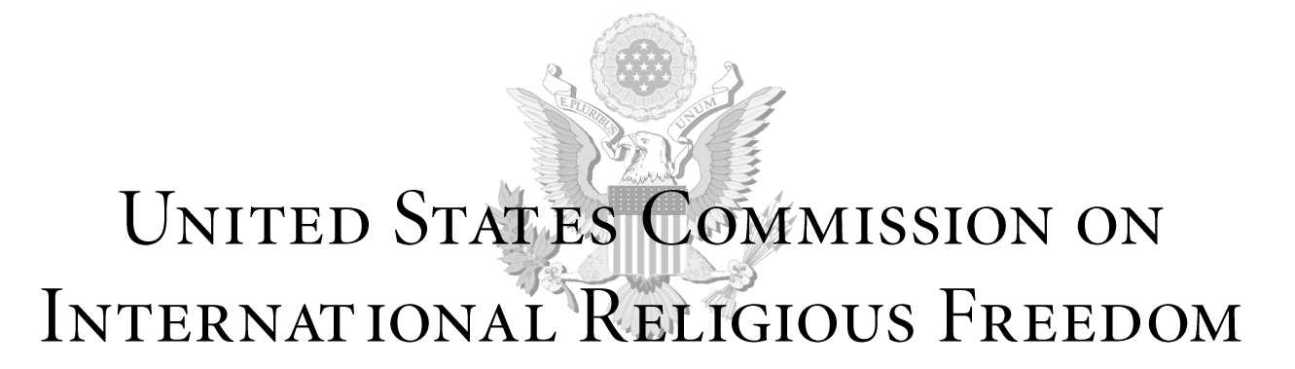

Testimony by Dr. Tenzin Dorjee, Chair
United States Commission on International Religious Freedom

Hearing on
“China’s War on Christianity and Other Religious Faiths”
Before the House Foreign Affairs Committee
Subcommittee on Africa, Global Health, Global Human Rights,
and International Organizations

September 27, 2018
2:00pm
Room 2255 Rayburn House Office Building

Chairman Chris Smith, Ranking Member Karen Bass, and other members of the Subcommittee: Good afternoon, and thank you for the opportunity to testify today on behalf of the U.S. Commission on International Religious Freedom, or USCIRF, about the Chinese government’s outright assault on persons of any faith, but particularly those it associates with foreigners, such as Christians and Muslims.

I am Tenzin Dorjee, USCIRF’s current chair and the only Tibetan Buddhist ever appointed to serve on the Commission. USCIRF is an independent, bipartisan U.S. federal government commission created by the 1998 International Religious Freedom Act, or IRFA. The Commission monitors the universal right to freedom of religion or belief abroad, using international standards to do so, and makes policy recommendations to Congress, the President, and Secretary of State.

I’m honored to be joined at this hearing by two esteemed colleagues who also work on international religious freedom: Bob Fu of ChinaAid and Tom Farr of the Religious Freedom Institute. I look forward to their testimonies.

USCIRF began reporting on China in our very first Annual Report and has continued to do so every year since because of that country’s systematic, ongoing, egregious violations of religious freedom. The State Department first designated China as a “country of particular concern”, or CPC, in 1999 and has done so in every instance the Department has made such designations, most recently in December 2017. And USCIRF has recommended the CPC designation for China every single year.

Regrettably, the conditions USCIRF first reported in China nearly two decades ago have not improved. In fact, the conditions have worsened under President Xi Jinping due to the “sinicization” and securitization of religion. Religions must accord with communist ideology, and religious freedom is most severely restricted in the name of national security. USCIRF has consistently raised these two pertinent issues at various hearings and events. Relatedly, USCIRF’s 2018 Annual Report depicted ongoing repression and discrimination directed at Tibetan Buddhists, Uighur Muslims, Protestants and Catholics, and Falun Gong practitioners. These abuses include:
- destruction or dismantling of houses of worship and religious symbols;
- forced evictions from and demolition of religious educational institutions;
- restrictions—related to the practice and study of one’s faith—on language, culture, attire, parents’ ability to name and teach their children, religious rituals and ceremonies, and freedom of movement;
- imprisonment of religious leaders and followers, as well as lawyers and human rights defenders advocating for religious freedom;
- prolonged disappearances and arbitrary detention without trial, denials of legal representation and medical care, and intimidation and physical assault—sometimes through torture—to force believers to renounce their faith;
- forced attendance—or even unlawful detention—at “re-education” or “indoctrination” facilities; and
- pressure to join state-sanctioned religious organizations.

The scope and scale of these violations is staggering. Perhaps the best way to convey China’s horrific religious freedom conditions is by highlighting the human element, such as the Chinese prisoners that are part of USCIRF’s Religious Prisoners of Conscience Project. Through that project, USCIRF Commissioners advocate on behalf of specific individuals imprisoned for their faith background or religious activity. In China, Commissioners are advocating for three such prisoners.

The Panchen Lama
Gedhun Choekyi Nyima, the Panchen Lama, holds the second highest position in Tibetan Buddhism and is one of the world’s longest-held prisoners of conscience. Chinese government authorities kidnapped the then six-year-old boy and his family on May 18, 1995. They have not been heard from since. Just days before Gedhun’s abduction, His Holiness the Dalai Lama chose him to be the 11th Panchen Lama. The Chinese government, in complete disregard for the Tibetan people, named its own Panchen Lama, though most Tibetan Buddhists reject this selection.

The Panchen Lama’s disappearance and detention is in the context of the Chinese government’s ongoing vilification of the Dalai Lama; its asserted control over the reincarnation system of Tibetan Buddhism that includes the Dalai Lama’s reincarnation; the destruction of important Buddhist sites at Larung Gar and Yachen Gar; the pervasive security presence throughout the Tibet Area, including inside monasteries and nunneries; and the imprisonment of countless Tibetans like language advocate Tashi Wangchuk, whose appeal of his five-year prison sentence was denied just this August. Chinese repression is so extreme that at least 153 Tibetans have self-immolated since February 2009 in support of religious freedom, human rights, and the return of the Dalai Lama to Tibet.

Gulmira Imin
On July 5, 2009, Gulmira Imin, a Uighur Muslim, participated in a demonstration following the deaths of Uighur migrant workers. Authorities accused her of helping to organize the demonstration, in part by posting information about it online. A court sentenced Ms. Imin to life in prison on charges of “splittism”, leaking state secrets, and organizing an illegal demonstration. Her only “crime” was defending her fellow Uighur Muslims.

When we think of a war on religion, Beijing’s overt criminalization of Islam certainly comes to mind. The government prevents Uighur Muslims from observing Ramadan, invades their everyday lives with pervasive security measures, prohibits children from attending mosque, and bans Uighur language instruction in schools. Worst of all the Chinese government is detaining approximately one million Uighur Muslims in unlawful detention camps, allegedly to provide “vocational training” to prevent extremism. Imagine the entire city of San Jose, California—population just over one million people—detained against their will. And the Chinese government is not just punishing those currently detained: authorities harass and intimidate their loved ones, cruelly separating families, and have inflicted severe trauma on generations of Uighurs impacted by gross ill-treatment, torture, and shame just because they are Muslim.

Hu Shigen
In August 2016, a Chinese court found underground church leader and religious freedom advocate Hu Shigen guilty of subversion and sentenced him to seven and a half years in prison and another five years’ deprivation of political rights. He was one of nearly 300 lawyers and activists arrested, detained, or disappeared as part of a nationwide crackdown that began on July 9, 2015, also known as the 709 Crackdown.

The already poor situation for Christians, like other religious groups, has markedly declined since new religious regulations came into effect on February 1 this year. Just days prior to the regulations, Chinese police used dynamite to annihilate the evangelical Golden Lampstand Church. More recently, authorities shut down Zion Church, one of Beijing’s largest unregistered Protestant house churches. Across several provinces, authorities have confiscated Bibles, demolished churches, moved or destroyed crosses and other religious symbols—sometimes replacing them with the Chinese flag —and arrested countless Christians. In an unprecedented display of frustration, hundreds of underground house church leaders and clergy have signed a statement calling out the Chinese government’s abuse of power and violations against religious freedom.

Each of these individuals are prisoners adopted by USCIRF Commissioners through our Religious Prisoners of Conscience Project, but sadly they represent only a small fraction of the thousands wrongly imprisoned in China, many because of their faith. I’m proud to advocate for both the Panchen Lama and Gulmira Imin, and my colleague Commissioner Gary L. Bauer is advocating on behalf of Hu Shigen.

Recommendations
It would be easy to think that there is little hope from such a bleak assessment. However, there are a number of steps the U.S. government can and should take to underscore religious freedom concerns in China.

First, the State Department must immediately redesignate China as a CPC for its systematic, ongoing, egregious violations of religious freedom. Under the Frank Wolf International Religious Freedom Act, CPC designations should have been made by the end of August, and USCIRF urges the State Department to make them as soon as possible.

Second, in addition to the appropriate sanctions available under IRFA subsequent to a CPC designation, the Administration should pursue targeted sanctions against specific Chinese officials and agencies under the Global Magnitsky Human Rights Accountability Act.

Third, the State Department and the entire Administration should build on the momentum of the historic Ministerial to Advance Religious Freedom and continue their bilateral and multilateral efforts to shine a light on religious freedom concerns in China, such as in the Ministerial’s Statement on China.

Fourth, the Administration and Members of Congress should pursue regular visits to areas in China deeply impacted by the government’s religious freedom abuses and raise religious freedom concerns—including cases of prisoners of conscience—whenever they interact with Chinese government counterparts. Congress should pass the Reciprocal Access to Tibet Act that would deny entry into the United States for Chinese government officials responsible for creating or administering restrictions on U.S. government officials, journalists, tourists, and others seeking to travel to Tibetan areas. Moreover, the U.S. Congress should more actively seek readouts from Administration officials about their interactions with China, in particular to inquire about discussions related to religious freedom.

Conclusion
Religious freedom is called a universal right for a reason: it belongs to everyone, everywhere. Everyone has the right have a faith or no faith at all, and no one has the right to control it for others. When the Chinese government attacks freedom of religion or belief in such a wholesale and brutal manner, it is incumbent upon us all to hold them to account. Not just because they have violated the norms and standards of a rules-based international order, but because, in so doing, Beijing has assailed humanity with its blatant disregard for the human conscience.

Thank you again for holding a hearing on such a timely and important subject.

